SEPTEMBER 2022 ENTRY

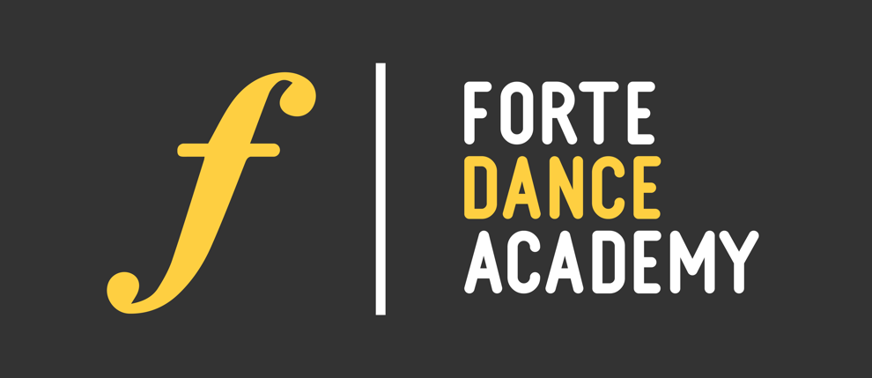

Thank you for considering applying to Forte Dance Academy. In order to make this audition process as smooth as possible please read the information below before submitting your application form.
- We request that you download and complete the application form and return it before the deadline.

- ALL questions on the application form must be answered, including questions on equality and diversity. Please be sure to read the application form through carefully before submission.

- All Application Photos/ Videos must be submitted, Application forms without photograph will not be processed. Please include one head shot.

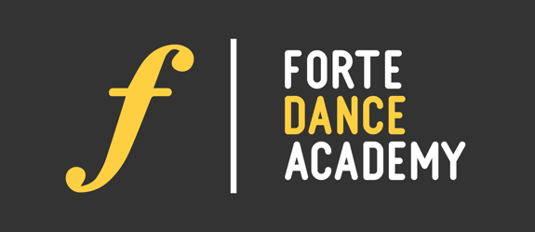
AUDITION NO:
OFFICE USE ONLY

HEAD SHOT

SEPTEMBER 2022

Name: _______________________________________

Age: _________________________________________

Nationality: ___________________________________

Dance School: _________________________________

Dance Teacher: ________________________________

IF YOU HAVE AUDITIONED PREVIOUSLY, YEAR OF AUDITION: _______________________

PERSONAL STATEMENT
Please use this page to tell us about your Achievements, Ambitions, and Inspirations, and why you would like to study at Forte Dance Academy

PERSONAL DETAILS
Please answer all Questions on this page.

Title (please tick one)
Mr. ☐ Mrs. ☐ Miss. ☐ Ms. ☐ Mx. ☐

Surname:
Postcode:

How long have you lived in Country of Residence?

Are you a national of a country other than your main passport issuing country? If yes please state which country.
NO ☐ YES ☐ Which Country?

Email Address:

Date of Birth:

Age on 01/09/2019:

Telephone Number:

Mobile Number:

Permanent Address:
Given Names:

EDUCATION, DANCE EXPERIENCE AND TRAINING
Please answer all Questions on this page with most recent information

CONTEMPORARY TRAINING
NAME OF SCHOOL:
Teacher's Name:
Please give a short history of your Contemporary Dance Training including, Technique/style studied and exams you have passed:

BALLET TRAINING
NAME OF SCHOOL:
Teacher’s Name:
Please give a short history of your Ballet Training including, Technique/style studied and exams you have passed:

EDUCATION
NAME OF MOST RECENT SCHOOL/COLLEGE:

LEAVING DATE:

Equality and Diversity
Please complete they following monitoring information

Encouragement to Disclose
Forte Dance Academy welcomes applications from all sections of the community regardless of ethnicity, age, gender, religion or disability. The information you give in this section is used for statistical and monitoring processes and does not form any part of the selection or admission process. You are encouraged to disclose any impairment or condition (for example, dyslexia, mental health, a physical, sensory impairment) at the earliest opportunity. We can then endeavour to support you at audition and during the course. All applicants who meet the criteria for entry to the School will be invited to audition.
Applicants should be reassured that any information you disclose is so that we can support you during the application process.
Injury
Our courses are rigorous and require high levels of energy and commitment. It would be very helpful if you could let us know if you have any performance related injuries or health difficulties, for example bone or joint problems, or if you are currently taking prescription drugs of any kind:

How did you hear about this course?

Internet Search ☐ Dance Teacher ☐ Workshop/Performance ☐ Current Student ☐
Website ☐ Magazine Advertisement ☐ Careers Advisor/School ☐ Other

Equality and Diversity
Please complete they following monitoring information

Ethnicity
Please tick the box which best describes your ethnic origin or cultural background.
10 White ☐ 39 Other Asian background ☐
15 Gypsy or Traveller ☐ 41 Mixed – White & black Caribbean ☐
21 Black or Black British – Caribbean ☐ 42 Mixed - White & Black African ☐
22 Black or British – African ☐ 43 Mixed – White & Asian ☐
29 Other Black background ☐ 49 Other Mixed Background ☐
31 Asian or Asian British – Indian ☐ 50 Arab ☐
32 Asian or Asian British – Pakistani ☐ 80 Other Ethnic background ☐
33 Asian or Asian British – Bangladeshi ☐ 98 I do not wish to give this information ☐
34 Chinese ☐

Disability
The information you give below will be used for statistical purposes only. Which of the following statements about disability is most appropriate to you? Please tick the appropriate box(es)
00 No known disability ☐ 54 Long Standing Illness or Health Condition e.g Epilepsy ☐
58 Blind/ Serious Visual Impairment ☐ 08 Two or more impairments and/or medical conditions ☐
57 Deaf/ Serious Hearing Impairment ☐ 53 Social/ Communication Impairment e.g Autistic spectrum ☐
56 Physical Impairment of Mobility Issues ☐ 51 A Specific Learning Difficulty e.g Dyslexia ☐
05 Personal Care Support ☐ 96 A disability, impairment or medical condition not listed ☐
55 Mental Health difficulties ☐ 00 I do not wish to give this information ☐
Specific support for Dyslexic Students
If you know that you are dyslexic, or have another specific learning difficulty we strongly encourage you to let us know as soon as possible. This will help us develop a Personal Learning Support Plan, and to assist UK based students to apply for the Disabled Students Allowance where you have not already done so.
End of Application

